B. In-Depth Explanation & Analysis
1. The Cause of Periodicity Why do properties repeat? Because electronic configurations repeat.
- Effective Nuclear Charge ( $Z_{\text{eff }}$ ): The net positive charge experienced by an outer electron. Across a period, protons increase, but shielding (inner electrons) remains constant. So, $Z_{\text{eff }}$ increases, pulling the shell closer.
- Shielding (Screening) Effect: Inner electrons repel outer electrons, "shielding" them from the nucleus. Down a group, new shells increase shielding significantly, overpowering the nuclear charge increase.
2. Trends in Ionization Enthalpy (IE)
- Definition: Energy required to remove the most loosely bound electron from an isolated gaseous atom.
- Trend: Increases → , Decreases ↓
- Crucial Exceptions:
  - Beryllium vs. Boron: Beryllium vs. Boron: Be ( $2s^{2}$ ) has higher IE than B ( $2s^{2}2p^{1}$ ) because the $s$-orbital is more penetrating (closer to nucleus) and stable than $p$.
  - Nitrogen vs. Oxygen: $N\left(2p^{3}\right)$ has higher IE than $O\left(2p^{4}\right)$ because the half-filled $p^{3}$ configuration is extra stable.
3. Electron Gain Enthalpy ( $Δ_{eg}H$ ) vs. Electronegativity
- Electronegativity: A qualitative tendency to attract shared electrons in a bond. (Fluorine is king).
- Electron Gain Enthalpy: A quantitative energy change when an atom accepts an electron.
- The Chlorine-Fluorine Anomaly: You'd expect F to have the most negative electron gain enthalpy. But Chlorine does. Why? F is so tiny that its electron cloud is crowded; adding another electron causes repulsion. Cl is larger and accommodates the new electron easily.
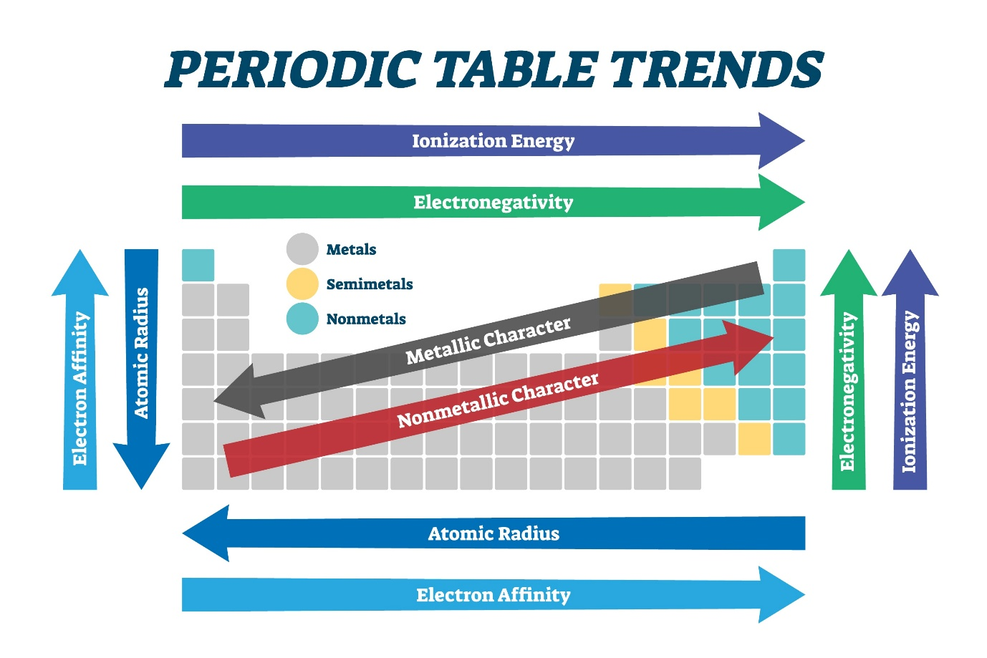
4. IUPAC Nomenclature ( $Z>100$ )
- Roots: $0=$ nil, $1=$ un, $2=$ bi, $3=$ tri, $4=$ quad, $5=$ pent, $6=$ hex, $7=$ sept, $8=$ oct, $9=$ enn.
- Example: $Z=119→$ Un (1) + un (1) + enn (9) + ium = Ununennium. Symbol: Uue.
Mentor insight: MCQ’s are common from this nomenclature.

